Java SE Project

Training And Placement Application

***SignUpFrame Documentation***

1. **SignUpFrame -**

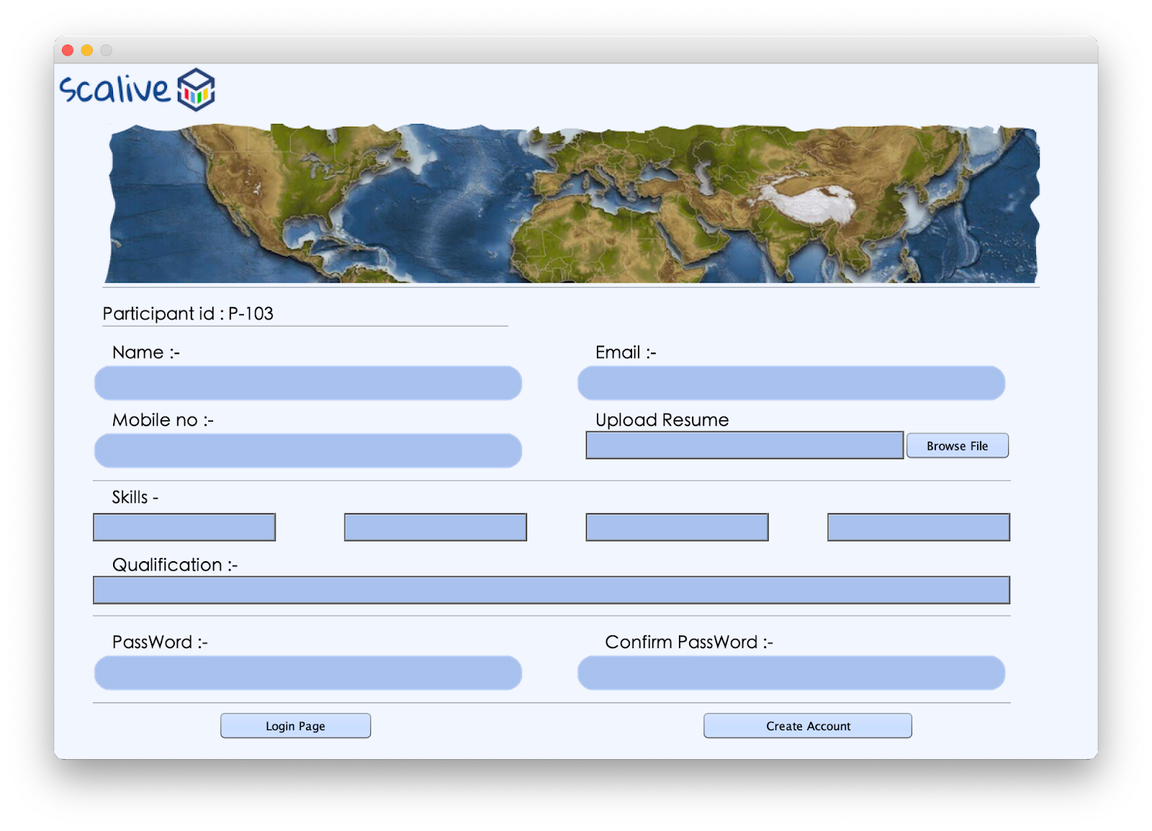

**2. STEPS TO BE DONE IN** **SignUpFrame**

In the **SignUpFrame** we need to do following steps:

1. Allow the user to go back to **login page**
2. Write code to display **Participant ID** as soon as the frame is **loaded**
3. Write code for the "**Create Account**" Button .
4. When this button is clicked it should add a **Participant Record** in the **Participants** table
5. **Allowing The User To Go To Login Page**

Same as before

1. **Writing Code For Generate Participant Id**

**THE TABLE USED IN SignUpFrame**

**Participants**

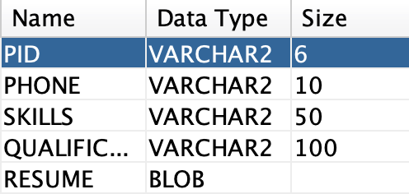

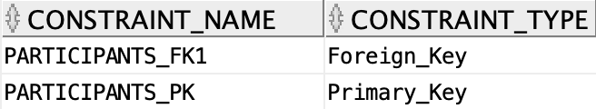

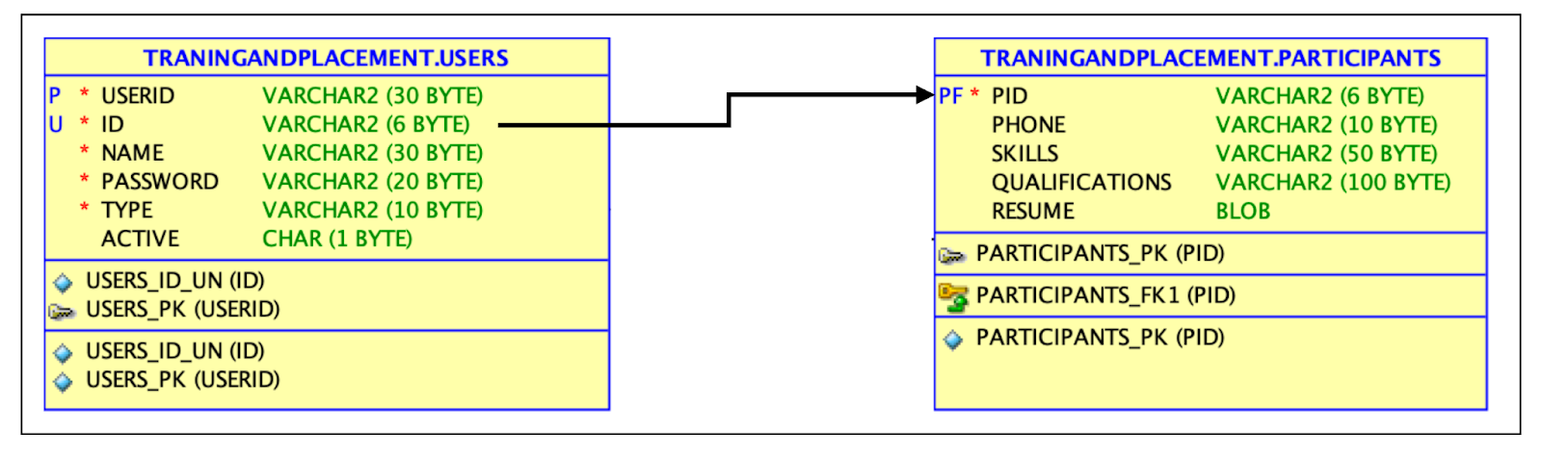

**The Participant POJO Class**

**public class ParticipantsPojo {**

**private String pId;**

**private String userId;**

**private String name;**

**private Long phone;**

**private String skills;**

**private String qualifications;**

**private String password;**

**private String type;**

**private File resume;**

**public String getType() {**

**return type;**

**}**

**public void setType(String type) {**

**this.type = type;**

**}**

**public String getPassword() {**

**return password;**

**}**

**public void setPassword(String password) {**

**this.password = password;**

**}**

**public String getpId() {**

**return pId;**

**}**

**public void setpId(String pId) {**

**this.pId = pId;**

**}**

**public String getUserId() {**

**return userId;**

**}**

**public void setUserId(String userId) {**

**this.userId = userId;**

**}**

**public String getName() {**

**return name;**

**}**

**public void setName(String name) {**

**this.name = name;**

**}**

**public Long getPhone() {**

**return phone;**

**}**

**public void setPhone(Long phone) {**

**this.phone = phone;**

**}**

**public String getSkills() {**

**return skills;**

**}**

**public void setSkills(String skills) {**

**this.skills = skills;**

**}**

**public String getQualifications() {**

**return qualifications;**

**}**

**public void setQualifications(String qualifications) {**

**this.qualifications = qualifications;**

**}**

**public File getResume() {**

**return resume;**

**}**

**public void setResume(File resume) {**

**this.resume = resume;**

**}**

**public ParticipantsPojo() {**

**}**

**}**

**Generating The Participant-Id**

**public static int getNewParticipantId()throws SQLException**

**The Code For getParticipantId()**

**public class ParticipantDAO {**

**public static int getNewParticipantId()throws SQLException{**

**Connection conn=DBConnection.getConnection();**

**Statement st=conn.createStatement();**

**ResultSet rs=st.executeQuery("Select max(pid) from participants");**

**int pId=101;**

**rs.next();**

**String strid=rs.getString(1);**

**if(strid!=null){**

**String id=strid.substring(3);**

**pId=Integer.parseInt(id)+1;**

**}**

**return pId;**

**}**

**The Code For addNewParticipant()**

**public static int addNewParticipants(ParticipantsPojo pt)throws SQLException,FileNotFoundException**

**{**

**Connection conn=DBConnection.getConnection();**

**PreparedStatement ps=conn.prepareStatement("select userid from users where userid=?");**

**ps.setString(1,pt.getUserId().toUpperCase().trim());**

**ps.setString(2,pt.getpId().trim());**

**ResultSet rs=ps.executeQuery();**

**if(rs.next()){**

**return -1;**

**}**

**ps=conn.prepareStatement("insert into users values(?,?,?,?,?,?)");**

**ps.setString(1, pt.getUserId());**

**ps.setString(2, pt.getpId());**

**ps.setString(3,pt.getName());**

**ps.setString(4,pt.getPassword());**

**ps.setString(5,pt.getType());**

**ps.setString(6, "Y");**

**int x=ps.executeUpdate();**

**int y=0;**

**if(x==1){**

**ps=conn.prepareStatement("insert into participants values(?,?,?,?,?)");**

**ps.setString(1,pt.getpId());**

**ps.setLong(2,pt.getPhone());**

**ps.setString(3,pt.getSkills());**

**ps.setString(4,pt.getQualifications());**

**FileInputStream resume = new FileInputStream(pt.getResume().getPath());**

**ps.setBlob(7,resume);**

**y=ps.executeUpdate();**

**}**

**return y;**

**}**

**The Code For SignUpFrame**

**public class SignUpFrame extends javax.swing.JFrame {**

**private File file;**

**private String pwd,cnfpwd;**

**public SignUpFrame() {**

**initComponents();**

**this.setLocationRelativeTo(null);**

**loadId();**

**}**

**private void loadId(){**

**try{**

**int pId=ParticipantDAO.getNewParticipantId();**

**lblPid.setText("P-"+pId);**

**}**

**catch(SQLException ex){**

**JOptionPane.showMessageDialog(null,"DB Error","Error In Generating HrID",JOptionPane.ERROR_MESSAGE);**

**ex.printStackTrace();**

**}**

**}**

**private boolean validateInputs(){**

**char[]chpwd=txtPwd.getPassword();**

**char[]chnfPwd=txtCnfPwd.getPassword();**

**if(txtName.getText().trim().isEmpty()||txtMail.getText().trim().isEmpty()||txtPhone.getText().trim().isEmpty()||chpwd.length==0||chnfPwd.length==0||txtSkill1.getText().trim().isEmpty()||txtSkill2.getText().trim().isEmpty()||txtSkill3.getText().trim().isEmpty()||txtSkill4.getText().trim().isEmpty()||txtFilePath.getText().trim().isEmpty()||txtQualification.getText().trim().isEmpty())**

**return false;**

**return true;**

**}**

**private void clearAll(){**

**txtName.setText("");**

**txtPhone.setText("");**

**txtMail.setText("");**

**txtSkill1.setText("");**

**txtSkill2.setText("");**

**txtSkill3.setText("");**

**txtSkill4.setText("");**

**txtPwd.setText("");**

**txtCnfPwd.setText("");**

**txtFilePath.setText("");**

**}**

**private boolean matchPasswords(){**

**pwd =String.valueOf(txtPwd.getPassword());**

**cnfpwd=String.valueOf(txtCnfPwd.getPassword());**

**return pwd.equals(cnfpwd);**

**}**

**private void BrowseFileBtnActionPerformed(java.awt.event.ActionEvent evt) {**

**JFileChooser fileChooser=new JFileChooser();**

**fileChooser.setDialogTitle("Select Your Reseume");**

**fileChooser.setFileSelectionMode(JFileChooser.FILES_ONLY);**

**int result=fileChooser.showOpenDialog(null);**

**if(result==JFileChooser.APPROVE_OPTION){**

**file=fileChooser.getSelectedFile();**

**txtFilePath.setText(file.getName());**

**}**

**}**

**private void btnCreateAccountActionPerformed(java.awt.event.ActionEvent evt) {**

**if(validateInputs()==false){**

**JOptionPane.showMessageDialog(null,"Please input all the fields","Incomplete Data!",JOptionPane.WARNING_MESSAGE);**

**return;**

**}**

**if(matchPasswords()==false){**

**JOptionPane.showMessageDialog(null,"Passwords do not match","Mismatched Passwords!",JOptionPane.WARNING_MESSAGE);**

**return;**

**}**

**try{**

**ParticipantPojo pt=new ParticipantPojo();**

**pt.setId(lblPid.getText().trim());**

**pt.setUserId(txtMail.getText().trim());**

**pt.setName(txtName.getText().trim());**

**pt.setPhone(txtPhone.getText().trim());**

**pt.setResume(file);**

**pt.setSkills(txtSkill1.getText().trim()+","+txtSkill2.getText().trim()+","+txtSkill3.getText().trim()+","+txtSkill4.getText().trim());**

**pt.setQualifications(txtQualification.getText().trim());**

**pt.setPassword(pwd);**

**pt.setType("Pt");**

**int result=ParticipantDAO.addNewParticipant(pt);**

**if(result==1){**

**JOptionPane.showMessageDialog(null,"Participant Added Successfully!","Success!!",JOptionPane.INFORMATION_MESSAGE);**

**clearAll();**

**loadId();**

**return;**

**}else if(result==-1){**

**JOptionPane.showMessageDialog(null,"Email-Id Already Taken!","Registration Failed!",JOptionPane.ERROR_MESSAGE);**

**}else{**

**JOptionPane.showMessageDialog(null,"Cannot Add The Record!","Registration Failed!",JOptionPane.ERROR_MESSAGE);**

**}**

**}**

**catch(SQLException ex){**

**JOptionPane.showMessageDialog(null,"SQL Error!","DB Problem,",JOptionPane.ERROR_MESSAGE);**

**ex.printStackTrace();**

**return;**

**}**

**catch(FileNotFoundException ex){**

**JOptionPane.showMessageDialog(null,"File Error!","File Problem,",JOptionPane.ERROR_MESSAGE);**

**ex.printStackTrace();**

**return;**

**}**

**}**